**DEPARTMENT OF COMPUTER & INFORMATION SYSTEMS ENGINEERING**

**BACHELORS IN COMPUTER SYSTEMS ENGINEERING**

**Course Code: CS-115**

**Course Title: Computer Programming**

**Complex Engineering Problem**

**FE Batch 2023, Fall Semester 2023**

#### Grading Rubric

**TERM PROJECT**

**Group Members:**

|  |  |  |
| --- | --- | --- |
| **Student No.** | **Name** | **Roll No.** |
| S1 | **Tahir Ali** | **CS-23058** |
| S2 | **Muhammad Arham Khan** | **CS-23047** |
| S3 | **Faizan Ahmed** | **CS-23052** |

|  |  |  |  |  |  |  |
| --- | --- | --- | --- | --- | --- | --- |
| **CRITERIA AND SCALES** | | | | **Marks Obtained** | | |
| **S1** | **S2** | **S3** |
| Criterion 1: Does the application meet the desired specifications and produce the desired outputs? (CPA-1, CPA-3) **[8 marks]** | | | |  |  |  |
| 1 | 2 | 3 | 4 |
| The application does not meet the desired specifications and is producing incorrect outputs. | The application partially meets the desired specifications and is producing incorrect or partially correct outputs. | The application meets the desired specifications but is producing incorrect or partially correct outputs. | The application meets all the desired specifications and is producing correct outputs. |
| Criterion 2: How well is the code organization? [2 marks] | | | |  |  |  |
| 1 | 2 | 3 | 4 |
| The code is poorly organized and very difficult to read. | The code is readable only to someone who knows what it is supposed to be doing. | Some part of the code is well organized, while some part is difficult to follow. | The code is well organized and very easy to follow. |
| Criterion 3: How friendly is the application interface? (CPA-1, CPA-3) [2 marks] | | | |  |  |  |
| 1 | 2 | 3 | 4 |
| The application interface is difficult to understand and use. | The application interface is easy to understand and but not that comfortable to use. | The application interface is very easy to understand and use. | The application interface is very interesting/ innovative and easy to understand and use. |
| Criterion 4: How does the student performed individually and as a team member? (CPA-2, CPA-3) [4 marks] | | | |  |  |  |
| 1 | 2 | 3 | 4 |
| The student did not work on the assigned task. | The student worked on the assigned task, and accomplished goals partially. | The student worked on the assigned task, and accomplished goals satisfactorily. | The student worked on the assigned task, and accomplished goals beyond expectations. |
| Criterion 5: Does the report adhere to the given format and requirements? [4 marks] | | | |  |  |  |
| 1 | 2 | 3 | 4 |
| The report does not contain the required information and is formatted poorly. | The report contains the required information only partially but is formatted well. | The report contains all the required information but is formatted poorly. | The report contains all the required information and completely adheres to the given format. |
| Total Marks: | | | |  |  |  |

_____________________

Teacher’s Signature

* **Problem Description:**

The aim of this project is to create an online shopping cart application, providing users with the ability to browse, select, and purchase products virtually. The application must also include user account management, cart functionalities, a shopping history feature, and purchasing system.

The advent of online shopping carts has revolutionized consumer habits. Formerly reliant on offline markets, people now overwhelmingly opt for the convenience of online orders. This shift is driven by the time-saving and accessible nature of virtual shopping. With the ability to browse products, compare prices, and complete transactions from any location, online shopping carts have become the preferred choice. The ease of adding or removing items, along with detailed product information and timely notifications, contributes to an enhanced shopping experience. This trend underscores a societal embrace of digital solutions, with online shopping carts offering a streamlined and efficient way to meet consumer needs.

* **Distinguishing features of your project:**

**1) Text-animation:**

Project showcases uniqueness through engaging text animations for enhanced user experience.

**2) Clear Screen:**

Implemented clear screen feature for better readability as content accumulates.

**3) f-string formatting:**

Integrated F-string formatting for efficient and readable code representation in the project.

**4) Implementing SHA-256 for secure the password:**

Implemented secure password handling by hashing and storing user inputs in the database for enhanced data security in the project.

**5) Dividing common task into functions:**

Structured the project with modular design, creating separate functions for common tasks to facilitate easy and efficient code management and invocation.

**6) Useful Comments:**

Enhanced code readability by including comments on nearly every line in the project, ensuring a user-friendly understanding of the codebase.

* **Most challenging part for you while working on the project:**

The most challenging aspects of the project encompassed the creation of an engaging user interface, efficient file handling, and the implementation of functions tailored for specific tasks.

* + 1. **Creating and managing Database:**

Crafting a visually appealing and intuitive user interface posed a significant challenge. Balancing aesthetics with functionality to engage users effectively required careful consideration of design principles.

* + 1. **Reading and writing data from/into file:**

Developing robust file handling mechanisms demanded meticulous attention. Creating, managing, and ensuring the secure reading and writing of data from files posed challenges in terms of data integrity and security.

* + 1. **Creating functions for specific task:**

Designing and implementing functions tailored for specific tasks required a deep understanding of the project's requirements. Ensuring these functions were efficient, error-free, and seamlessly integrated with other components added complexity.

* + 1. **Intregation of While/For loops:**

Integrating effective while and for loops proved challenging. Optimizing loop structures to enhance the application's performance and responsiveness required careful consideration of the project's logic and requirements.

* **Any new thing learnt in Python while working on the project:**

1. **Mastery of Functions:**

Acquired in-depth knowledge of Python functions, mastering their creation and application for modular and efficient code.

1. **Utilizing the os Module:**

Explored the os module for effective interaction with the operating system, enhancing file management and system-level operations.

1. **Integration of Functions Across Files:**

Learned to integrate functions from different files, ensuring code organization and promoting a modular project structure.

1. **Strategies for Large-Scale Projects:**

Discovered effective strategies for collaborative large-scale project management, emphasizing communication and coordinated task allocation.

1. **F-String Formatting:**

Implemented F-string formatting for clearer and more concise representation of dynamic data within the project.

1. **Hashlib with SHA-256:**

Employed hashlib to implement SHA-256 hashing for secure storage and handling of sensitive user information.

1. **Mastery of Control Statements:**

Gained proficiency in using control statements such as pass and continue, enhancing code logic and flow control.

1. **Comprehensive Use of Time Module:**

Explored various methods within the time module for efficient time-related operations and scheduling.

1. **Understanding the Return Statement:**

Delved into the nuances of the return statement, mastering its implementation for effective function outputs.

1. **Text Animation Using Loops and Time:**

Developed skills to animate text dynamically using only for loops and the time module, enhancing user interface engagement.

1. **Effective Team Coordination:**

Learned how to coordinate effectively with team members, ensuring seamless collaboration and successful project execution.

1. **File Handling and Database Creation:**

Acquired expertise in file handling and database creation, crucial for efficient data storage and retrieval within the project.

1. **Exploring Different IDEs:**

Explored various Integrated Development Environments (IDEs) to identify and leverage tools that enhance the development process.

1. **Interaction with AI Tools:**

Discovered how to give prompts to AI Tools, utilizing its capabilities to enhance project functionalities.

1. **Reading Python Documentation:**

Learned the skill of effectively reading and implementing Python documentation based on project requirements.

1. **Varied Methods for Data Structures:**

Explored diverse methods of using dictionaries, lists, and tuples, optimizing data structures for different project functionalities.

* **Individual contributions of each group member in the project:**
  + - 1. **Tahir Contribution:**

Tahir played a pivotal role in the inception and initial stages of our project, spearheading the creation of the account creation and login functionalities. From the project's outset, Tahir assumed responsibility for orchestrating the application's initiation, guiding users through the account creation and login processes seamlessly. His contribution extended beyond mere functionality, as he incorporated engaging text animations using f-string formatting, adding a dynamic and visually appealing layer to the project. Furthermore, Tahir demonstrated his analytical and organizational skills by crafting a comprehensive algorithm in the form of a flow chart, mapping out the entirety of our program. This intricate flow chart served as a roadmap, providing clarity on the program's structure and logic. Additionally, Tahir took charge of designing the entire program, ensuring that it not only functioned effectively but also adhered to a well-thought-out and visually cohesive design.

* + - 1. **Arham Contribution:**

Arham assumed a key role in the project by overseeing the coding aspects related to 'Products' items. His responsibilities spanned from developing the functionality to display products to coding mechanisms for adding items to the cart, removing them, and facilitating direct purchases when users opt for immediate transactions. Arham's expertise in these critical components ensured a seamless and efficient user experience throughout the product management process.Beyond coding, Arham took on the responsibility of crafting the project's report, showcasing his aptitude for communication and documentation. He actively engaged in idea-sharing sessions with group members, contributing to a collaborative and well-rounded project development approach.

* + - 1. **Faizan Contribution:**

Faizan played a crucial role alongside Tahir in establishing the account creation and login system, showcasing collaborative teamwork. His contribution extended beyond implementation, as Faizan actively shared insightful ideas that enriched our project. He demonstrated his commitment by not only providing conceptual input but also by creating a model for the account creation and login system, contributing to the visual representation of these critical functionalities.Furthermore, Faizan's influence extended to the program's interface, where he contributed ideas to enhance user interaction. His holistic approach, encompassing both technical implementation and conceptual ideation, underscores his integral role in shaping the project's trajectory.

* **Future expansions, if any:**

1. **GUI Implementation for an Interactive Interface:**

Explore the integration of a graphical user interface (GUI) to enhance the overall user experience and interactivity.

1. **Payment Integration:**

Implement secure and convenient payment methods to facilitate seamless transactions within the platform.

1. **Social Media Integration for Account Management:**

Enhance user convenience by allowing account creation and login through social media platforms, streamlining the onboarding process.

1. **Strengthen Database Security:**

Upgrade to a more robust database system to ensure heightened security for user details, including login credentials.

1. **Advertisement Monetization:**

Introduce advertisement modules to generate revenue, capitalizing on the platform's user engagement.

1. **Wishlist Cart Feature:**

Implement a wishlist cart, allowing users to save out-of-stock items for future purchase and aiding sellers in identifying product demands.

1. **Stock Remaining Alerts for Sellers:**

Integrate an alert system to notify sellers about low stock levels, ensuring timely restocking and minimizing product unavailability.

1. **Discount Coupon System:**

Develop a discount coupon system to attract and retain customers, fostering loyalty and encouraging repeat purchases.

1. **CLI Design Enhancements:**

Refine and enhance the Command Line Interface (CLI) design for improved aesthetics and user interaction.

1. **Web Interface Integration:**

Explore the integration of a web-based interface, expanding accessibility and catering to a broader user base.

1. **Blockchain Concepts Integration:**

Introduce and integrate blockchain concepts, such as smart contracts, to enhance security and transparency in transactions between sellers and users.

1. **Suggestion System with Machine/Deep Learning:**

Implement a sophisticated suggestion system leveraging machine or deep learning algorithms to provide personalized product recommendations based on user preferences.

1. **Wallet System Introduction:**

Introduce a wallet system for users, enabling them to store credits or loyalty points for future purchases. These future expansions aim to not only improve the existing functionalities but also introduce advanced features, ensuring the Online Shopping Cart Project remains innovative, secure, and user-friendly.

* **List of references, if any:**

1. OpenAI - Chat GPT: <https://www.openai.com/>
2. W3Schools: <https://www.w3schools.com/>
3. Python Official Documentation: https://docs.python.org/
4. GeeksforGeeks: <https://www.geeksforgeeks.org/>

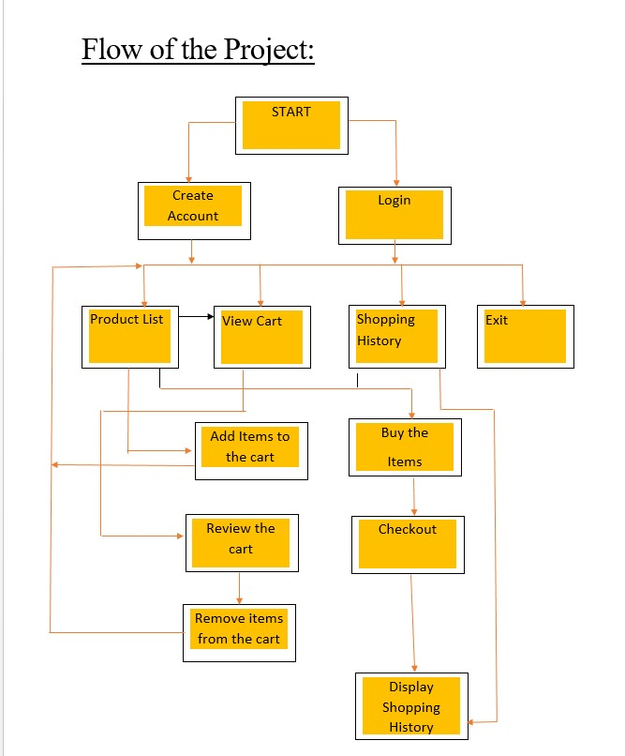

* ScreenShots:

